CONSTRUCTION OF DUAL CIRCUIT TRANSMISSION LINES AND SUBSTATIONS

TERMS OF REFERENCE

ENVIRONMENTAL AND SOCIAL IMPACT ASSESSMENT STUDY

BACKGROUND AND PROJECT DESCRIPTION
The Government of Grenada (GOG) has secured funding through the World Bank (WB) to pursue the Renewable Energy Infrastructure Investment Facility (RREIIF). The Project Development Objective (PDO) is to increase the share of utility-scale renewable energy generation and private-sector participation in renewable energy development in Grenada. The first participating countries are, Saint-Lucia, Grenada and Saint Vincent and the Grenadines, accompanied at regional level by the Eastern Caribbean Central Bank (ECCB) and the Eastern Caribbean Partial Credit Guarantee Corporation (ECPCGC). In Grenada, the Project Implementing Entities are Grenlec and the GOG.

Grenlec currently has three feeders that serve the North of the Island. Due to the distance constraints and increases in the load demand, these feeders can no longer sustain any future load growth to the North and Northeastern parts of the Island. The dual circuit transmission to Pearls and then on to Plains will provide urgently needed capacity to the north of the Island to sustain future growth in demand. This will also improve the resiliency of Grenlec’s network with shorter feeders now served by two transmission lines taking diverse routes. Additionally, the transmission network will now link the Northeast of Grenada, which has lands with potential for Solar PV development and the South of the island, where 45% of the load demand concentrates. It is anticipated that sometime in the near future, the land at Pearls will be developed into a Solar PV farm with associated Battery Energy Storage System (BESS). The Solar PV and BESS systems will interconnect to the Grid via the Pearls substation.

Existing studies
The following studies have been undertaken. These will be shared with the consultant.
- Environmental and Social Impact Assessment PV Solar Farm at Simon, St Andrews & Plains, St Patrick’s, May 28th 2015. (Hydrology Study is included)
- Geo-Technical Investigation Report for Solar P.V. Sites at Pearls and Plains for Grenlec, April 21st, 2015.
- Solar PV Screening Assessment, October 4th 2013.
- Pearls Topographic Survey, April 2015.
- ESIA for the MBIA Solar PV, BESS and Transmission project, September 2025 (disclosed).
- ESMP for the MBIA Solar PV, BESS and Transmission project. September 2025 (disclosed).
- ESMP for Grenada’s Battery Energy Storage Project, November 2024
- ESIA for Grenlec’s Battery Energy Storage Project at the MBIA, November 2024

- Objectives and Scope of the Assignment:

  - Objective
The overall objective of the assignment is to assess the environmental and social impacts of the proposed transmission lines, substations (the project) and the potential Solar PV farm with associated Battery Energy Storage System (BESS) at Pearls through an Environmental and Social Impact Assessment (ESIA) and provide mitigation measures in an Environmental and Social Management Plan (ESMP). The ESMP will be used by the Owners Engineer and design, construction, and operational contractors of the Project. The ESIA process will also aim at engaging with relevant stakeholders and enhancing adhesion to the Project.
In preparing the Environmental and Social Impact Assessment the Consultant will ensure compliance with:
- Current environmental and social regulations and standards in the country
- The World Bank’s Environmental and Social Framework and other World Bank procedures and guidelines on conducting environmental impact assessment.
- The World Bank Group’s Environmental, Health and Safety Guidelines (EHSGs)
- Environmental and Social Management Framework (ESMF) of the Project
- Stakeholder Engagement Plan (SEP) of the Project

The Consultant is expected to prepare and submit their own detailed work methodology and
approach to fulfil the assignment requirements given the risks covered under this TOR as part of
the Inception Report.
The detailed objectives of the ESIA are:
- To screen the sub-projects for potential environmental, health and safety and social risks and impacts;
- To provide baseline information about the environmental, social, economic and cultural conditions in the project area.
- To identify, analyze and evaluate the type and extent of likely potential environmental and social impacts and risks of the proposed investments as well as the significance, magnitude and distribution of beneficial or adverse effects of the proposed project on the existing biophysical, health and safety, social and cultural components.
- To assess and evaluate potential environmental and social (e.g. resettlement, if any) impacts of alternative options to the proposed routes and substations locations.
- To document the consultations with Project stakeholders in the process of development of the ESIA, and how these were taken into account in the design of mitigation measures.
- To propose monitoring and evaluation arrangements, as well as a budget to address identified environmental and social risks and impacts.
- To prepare an Environmental and Social Management Plan (ESMP) which is in line with the findings of the ESIA on all environment and social aspects as outlined above. The ESMP shall:
- outline environmental management and social mitigation/enhancement measures to adopt during pre-construction, construction and operations of the project,
  - propose measures for preventing, minimizing, mitigating or compensating for the adverse environmental and social impacts and risks and enhancing beneficial impacts, including costs of the measures and monitoring requirements,
  - propose consultation mechanisms for consultations with the various stakeholders, including project affected people,
  - detail the project-related grievance channels and mechanisms;
  - propose institutional strengthening measures to ensure the Borrower (implementing agency) is able to effectively and efficiently implement the proposed environmental and social mitigation measures.

2.2. Scope of the Assignment
The Assignment relates to the construction of transmission lines and substations as follows:
Transmission Lines | Voltage (kV) | Length (km)
Queens Park to Pearls via the Grenville feeder route | 33 or 66 (TBD) | 24.34
Queens Park to Pearls via the Industrial feeder route | 33 or 66 (TBD) | 33.61
Pearls to Plains (route 1) | 33 or 66 (TBD) | 9.79
Pearls to Plains (route 2) | 33 or 66 (TBD) | 9.52

No | Substation name | Voltage, kV | Capacity  MVA | Notes
1 | Pearls | 33 or 66 (TBD) | TBD
2 | Plains | 33 or 66 (TBD) | TBD | Currently being used as a small Solar PV farm.

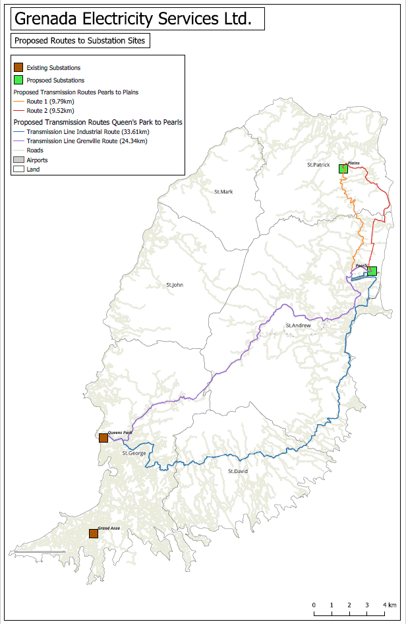

3. Tasks
A. Screening and Inception Report

The Consultant is required to review available literature on the proposed activity and its potential risks and impacts. Literature available to GRENLEC shall be provided to the consultant, which will serve as a starting point for the consultant to gather environmental and social information pertaining to the project.

Using the template in the Project’s ESMF and the information from the literature review, screening shall be undertaken. The screening should identify the potential risks and the level of risk of the sub-project activities.

The output of the first task will be an inception report. The inception report will detail the findings of the screening, initial literature review, methodology, timeline, institutional and logistical arrangements, challenges and risks, implementation plan and next steps anticipated for the detailed study. This will be approved by GRENLEC prior to starting the detailed ESIA study.

B. ESIA
The Consultant will conduct an ESIA of the proposed works, which should involve broad stakeholder consultation, especially in the local communities. Consultations should be representative and stakeholders should be disaggregated by sex, age, and disability to ensure differing perspectives are incorporated. Based on the ESIA, an Environmental and Social Management Plan (ESMP) should be developed. The ESIA shall include the following broad activities:

Baseline survey
The Consultant is required to collect, collate, and present baseline information on the existing environmental and social characteristics of, within and around the project sites/area of influence. This description involves presenting data directly relevant to decisions about project location, design, operation, and/or mitigation measures, including:
- Physical environment (topography, landforms, geology, soils climate and meteorology, air quality, hydrology, etc.).
- Biological environment (i.e., flora and fauna types and diversity, endangered species, sensitive habitats, forests, protected and sensitive areas, etc.).
- Socio-economic and cultural environment, (i.e., population, project related land acquisition requirements, land use and land use patterns, community structure, cultural properties, visual/aesthetic changes, labour influx risks; labour workforce, risks of SEA/SH etc.) In addition, the baseline information will:
  - Identify any changes anticipated before the project commences
  - Identify and estimate the extent, quality, accuracy and reliability of available data, key data gaps, and uncertainties associated with predictions, and specific topics that do not require further attention
  - Present summary data in a geographic format using the transmission line alignment sheets.
  - Include maps and other visuals as applicable.

Policy, Legislative and Regulatory and Institutional Framework
The Consultant shall review the national legislative and regulatory framework and World Bank ESF and other documents as applicable to environmental and social management as well as international conventions and treaties relevant to the proposed project. Laws and permits applicable to the project will be indicated.

Impact identification and assessment
The environmental and social impact assessment will predict and assess the project's potential positive and negative environmental and social impacts and risks that might change the baseline conditions, in quantitative terms to the extent possible, during the pre-construction, construction and operation phases. The Consultant shall differentiate between short, medium and long-term impacts; estimate the magnitude of impacts, and identify site-specific impacts.

The impact identification shall also include occupational health and safety concerns likely to arise as a result of construction and operations including worksite health and safety; labor camps/out of area workers etc.

Analysis of Alternatives
The assessment should include an analysis that would examine different alternatives with the objectives of minimizing environmental, health, safety and social impacts of the project:
- Description of the alternatives
- Comparing the positive and negative impacts expected from the project and other technical and economic alternatives including the "Do-Nothing" alternative
- Propose preferred alternatives with justification

Mitigation Measures
Identify mitigation measures and significant residual negative impacts that can not be mitigated and to the extent possible assess the acceptability of those residual negative impacts.

Appendices as needed

C. ESMP
The Consultant shall develop a comprehensive environmental and social management plan for managing the impacts during pre-construction, construction and operation phases. This will provide time frames and implementation mechanisms, reporting responsibilities, description and technical details of monitoring measures, assessment of the institutional needs, staffing requirements and cost outlay for implementation. The plan shall also include measures to prevent health hazards and to ensure safety in the working environment for the employees and the communities adjacent to the project sites and project affected people. It will follow the Mitigation Hierarchy. It will include:

- Mitigation Measures
This should identify and summarize all anticipated adverse environmental and social impacts in all phases of the project and describe with technical details each mitigation measure, including the type of impact to which it relates and the conditions under which it is required (e.g., continuously or in the event of contingencies), together with designs, equipment descriptions, and operating procedures, as appropriate.

- Monitoring Plan
This should identify the monitoring objectives and specify the type of monitoring, with linkages to the impacts assessed in the ESIA and the mitigation measures described. This is meant to provide (a) a specific description, and technical details, of monitoring measures, including the parameters to be measured, methods to be used, sampling locations, frequency of measurements, detection limits (where appropriate), and definition of thresholds that will signal the need for corrective actions; and (b) monitoring and reporting procedures to (i) ensure early detection of conditions that necessitate particular mitigation measures, and (ii) furnish information on the progress and results of mitigation.

- Institutional Arrangements and Capacity Development
- Describe institutional arrangements, responsibilities and procedures for all actors to carry out each of the mitigatory and monitoring measures (e.g., for operation, supervision, enforcement, monitoring of implementation, remedial action, reporting, and staff training).
- Include training requirements for all entities throughout the project cycles.

- Contractor clauses
Provide site-specific Environmental and Social contractual clauses that should be included in the bidding documents and contracts for the construction works to ensure the mitigation measures are implemented by the contractor.
- Grievance Redress Mechanism
  - Review and improve if necessary the GRM procedures for receiving, handling and resolving complaints related to the Project, including without limitation available channels to receive complaints and make appeals and timelines for responding to complaints.

- Cost Estimates:
For all three aspects (mitigation, monitoring, and capacity development), the ESMP should include (a) an implementation schedule for measures that must be carried out as part of the project, showing phasing and coordination with overall project implementation plans; and (b) the capital and recurrent cost estimates and sources of funds for implementing the ESMP. These figures are also integrated into the total project cost tables.

- Chance Find Procedures
Describe the ‘Chance Find’ procedures in the event physical cultural resources are encountered during project implementation.

Consultations
The Consultant shall carry out public consultation(s) to collect the views and opinions of the project’s key stakeholders (including potential project affected people in local communities) on the project’s risks, impacts and benefits. A summary of the consultations including how the feedback received is being incorporated into the design shall be incorporated into the ESIA and ESMP reports.

4. Team composition and qualification requirements for the Key Experts
The Consultant is responsible for providing a suitably qualified team. All team members should speak fluent English.

Firm-level requirements
- The firm must be a legally registered consulting entity in good standing
- The firm should have a minimum of 4-5 years of demonstrated experience in conducting ESIAs and ESMPs for infrastructure projects.
- The firm must have prior experience in the energy sector, and ideally in electricity transmission and distribution infrastructure projects and/or solar projects. It should be able to demonstrate completion of at least one to two ESIAs of comparable nature, with references and project descriptions included in the proposal.
- The firm must have demonstrated experience preparing ESIAs in compliance with the requirements of international financial institutions.
- Experience working in small-island developing states (SIDS) or the Caribbean region is strongly preferred
- The firm must demonstrate sufficient expertise to deliver this assignment including:

Team Leader / Environmental Specialist
Qualifications
- Master's Degree in Environmental Science, Environmental Engineering, Natural Resource Management, or a related field.
- Professional certification in environmental assessment or environmental management is an asset.
Experience
- Minimum of eight (8) years of professional experience in environmental assessment and management.
- Demonstrated experience leading and managing multidisciplinary ESIA assignments for infrastructure, energy, transmission, distribution, or renewable energy projects.
- Proven experience in preparing Environmental and Social Impact Assessments (ESIAs) and Environmental and Social Management Plans (ESMPs).
- Minimum of three (3) years of project and team management experience.
- Familiarity with the World Bank Environmental and Social Framework (ESF), Environmental, Health and Safety (EHS) Guidelines, and international environmental safeguard requirements.
- Experience working in Small Island Developing States (SIDS) or the Caribbean region is highly desirable.
- Excellent report writing, stakeholder engagement, and communication skills.

Social Development Specialist
Qualifications
- Master's Degree in Social Sciences, Sociology, Anthropology, Development Studies, Social Development, or a related field.
Experience
- Minimum of five (5) years of professional experience in social impact assessment and social risk management.
- Demonstrated experience in the preparation of social assessments and social management plans for infrastructure or energy sector projects.
- Experience in stakeholder engagement, community consultations, grievance redress mechanisms, labor management, and social inclusion.
- Proven experience assessing and managing risks related to land acquisition, resettlement, labor and working conditions, gender-based violence (GBV), sexual exploitation and abuse/sexual harassment (SEA/SH), and vulnerable groups.
- Familiarity with the World Bank Environmental and Social Standards (ESS), particularly ESS1, ESS2, ESS4, ESS5, and ESS10.
- Experience working in Small Island Developing States (SIDS) or the Caribbean region would be an advantage.
- Strong analytical, facilitation, and report-writing skills.
In addition, the team should collectively include the following competencies:
- Environmental impact assessment
- Social impact assessment)
- Stakeholder engagement
- Labor issues
- Occupational health and safety risk identification and management
- Terrestrial ecology / natural habitats
- Grievance Management

5. Deliverables:
- Inception report : 15 days after contract signature (25% of contract value)
- Draft ESIA, including ESMP : 3 months after submission and approval of inception report (50% of contract value)
- Final ESIA, including ESMP : 1 month after receipt of final comments on draft ESIA (25% of contract value)
6. Duration:
- 5 months (estimated August to December2026)

7. Implementation Arrangements:
- Site and transmission route tour with Grenlec.
- Point of Contact: Kennard Lalsingh, Deputy Project Manager World Bank for CEGEB & RREIIF. klalsingh@grenlec.com

